## Reports Menu/Daily Reports/Daily Audit Listing

Request:

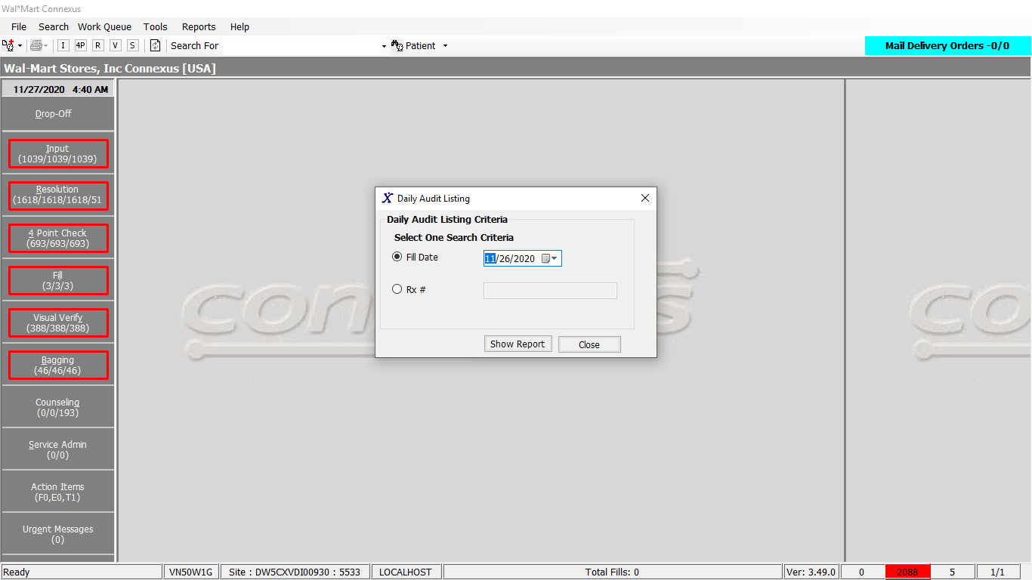

Response:

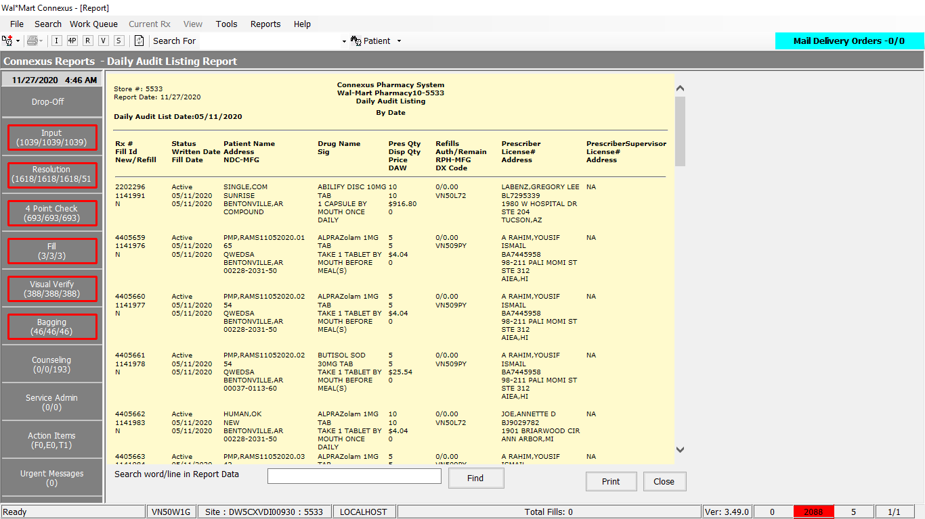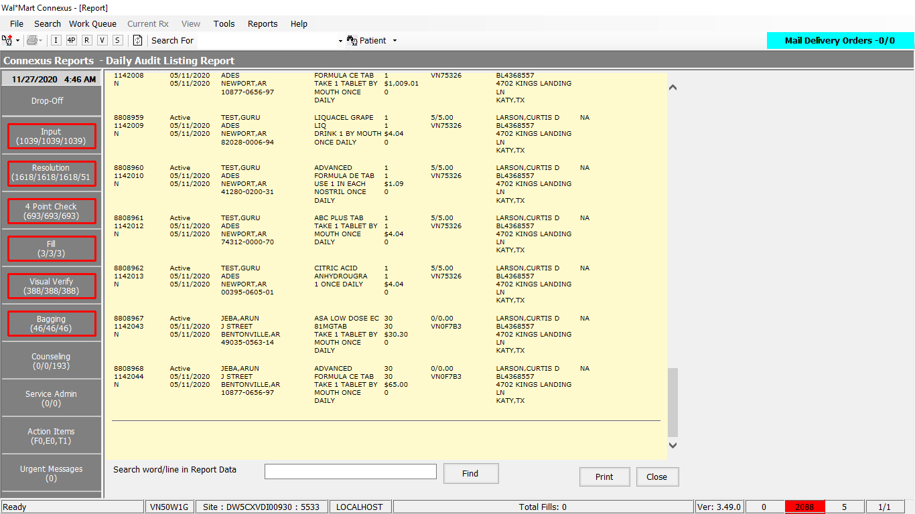

Queries:

1. Friend Const GetDailyAuditListingCashPay As String = "SELECT rx.rx_nbr, rxf.rx_fill_id,SUBSTR(rx.rx_entry_userid,0,3) InputTech," &

"CASE WHEN (SELECT COUNT(rx_id) FROM rx_fill refill " &

"WHERE rxf.rx_id = refill.rx_id AND refill.status_code = 20401 AND refill.fill_type_code IN (7003,7000)) = 1 THEN 'N' " &

"ELSE CAST((SELECT COUNT(rx_id) FROM rx_fill refill WHERE rxf.rx_id = refill.rx_id " &

"AND refill.status_code = 20401 AND refill.fill_date <= ? AND refill.fill_type_code IN (7003,7000)) AS CHAR(4)) END refillno," &

"pct1.code_desc rxf_status, rx.rx_written_date, rxf.fill_date, rxf.fill_qty, rx.remaining_qty," &

"TRIM(NVL(pat.last_name,'')) || ',' || TRIM(NVL(pat.first_name,'')) || ' ' || TRIM(NVL(pat.middle_name,'')) PatName," &

"sa.address_line_1 pat_address1, sa.address_line_2 pat_address2, sa.city_name pat_city, sa.state_prov_code pat_state, " &

"TRIM(NVL(dr.last_name,'')) || ',' || TRIM(NVL(dr.first_name,'')) || ' ' || TRIM(NVL(dr.middle_name,'')) DRName, " &

"sa1.address_line_1 pres_address1, sa1.address_line_2 pres_address2, sa1.city_name pres_city, sa1.state_prov_code pres_state,NVL(rpl.license_nbr,drlic.license_nbr) DEA," &

"TRIM(NVL(ps.last_name,'NA')) || ',' || TRIM(NVL(ps.first_name,'')) PrescriberSupervisor, psa.address_line_1 pres_super_address1, psa.address_line_2 pres_super_address2, " &

"psa.city_name pres_super_city, psa.state_prov_code pres_super_state, psl.license_nbr super_DEA," &

"pp.short_name , rxf.rph_of_rec_userid, " &

"CASE WHEN rx.compound_ind ='Y' THEN 'COMPOUND' ELSE pi.ndc_nbr END ndc_nbr, " &

"rx.fill_qty pres_qty, pct2.code_abbr daw, rx.expanded_sig_txt sig, " &

"CASE WHEN rxf.pos_ts IS NULL THEN rxf.pos_due_amt ELSE rxf.pos_sale_amt END price," &

"CASE WHEN rx.refill_auth_code IS NULL THEN CAST(rx.refills_auth_nbr AS VARCHAR(3)) " &

"WHEN rx.refill_auth_code IS NOT NULL THEN (SELECT code_desc FROM pharmacy_code_txt WHERE code_id = rx.refill_auth_code) END refill_auth_nbr, " &

"CAST(refills_auth_nbr + 1 - (ROUND(( (SELECT NVL(SUM(rxf2.fill_qty) ,0) FROM rx_fill rxf2 WHERE rxf.rx_id = rxf2.rx_id AND rxf2.status_code = 20401 AND " &

"rxf2.fill_type_code = 7000 AND rxf2.fill_date <= ?) + (SELECT NVL(SUM(rxf_orig.fill_qty),0) FROM rx_fill rxf_final, rx_fill rxf_orig, partial_fill pf " &

"WHERE rxf.rx_id = rxf_final.rx_id " &

"AND rxf.rx_id = rxf_orig.rx_id AND rxf_final.status_code = 20401 AND rxf_final.rx_fill_id = pf.fnl_partl_fill_id AND rxf_orig.rx_fill_id= pf.orig_rx_fill_id AND " &

"rxf_final.fill_date <= ?)) / rx.fill_qty,1)) AS VARCHAR(4)) refillsremain, ptt.patient_type_desc, TRIM(NVL(own.last_name,'')) || ',' || TRIM(NVL(own.first_name,'')) owner_name " &

",rest.expiration_ts, rcdd.rx_clasf_value_code FROM rx, rx_fill rxf, rx_fill_item rfi, " &

"OUTER pharmacy_code_txt pct, pharmacy_code_txt pct1, prescriber dr, patient pat, patient_type_txt ptt, " &

"OUTER(related_patient rp, patient own)," &

"OUTER prescriber_license drlic," &

"OUTER rx_prsbr_license rpl, subject_address sa1, pharmacy_offering:pharmacy_product pp, " &

"pharmacy_offering:pharmacy_item pi, pharmacy_code_txt pct2, subject_address sa," &

"OUTER prescriber ps," &

"OUTER subject_address psa," &

"OUTER prescriber_license psl,OUTER rx_restrict rest, " &

"OUTER rx_clasf_diagnosis_detail rcdd " &

"WHERE rx.delegating_prsbr_id=ps.prescriber_id " &

"AND psa.subject_type_code=303 " &

"AND psa.subject_id= rx.delegating_prsbr_id " &

"AND psl.prescriber_id=rx.delegating_prsbr_id " &

"AND psl.license_type_code=800 " &

"AND rx.refill_auth_code = pct.code_id " &

"AND rx.rx_id = rxf.rx_id AND rx.rx_id = rest.rx_id AND rest.restrict_type_code=400 " &

"AND rx.rx_version_seq_nbr = rxf.rx_version_seq_nbr " &

"AND rx.rx_id = rcdd.rx_id " &

"AND rx.rx_version_seq_nbr = rcdd.rx_version_seq_nbr " &

"AND rcdd.rx_clasf_code = 1200 " &

"AND rcdd.rx_diagnosis_type_code = 1301 " &

"AND rxf.daw_code=pct2.code_id " &

"AND pat.patient_id = rp.patient_id " &

"AND rp.relt_patient_id = own.patient_id " &

"AND rp.relt_reason_code = 1504 " &

"AND ptt.patient_type_code = pat.patient_type_code "

2. Friend Const GetDailyAuditListingExcludeCashPay As String = "SELECT rx.rx_nbr, rxf.rx_fill_id,SUBSTR(rx.rx_entry_userid,0,3) InputTech," &

"CASE WHEN (SELECT COUNT(rx_id) FROM rx_fill refill " &

"WHERE rxf.rx_id = refill.rx_id AND refill.status_code = 20401 AND refill.fill_type_code IN (7003,7000)) = 1 THEN 'N' " &

"ELSE CAST((SELECT COUNT(rx_id) FROM rx_fill refill WHERE rxf.rx_id = refill.rx_id " &

"AND refill.status_code = 20401 AND refill.fill_date <= ? AND refill.fill_type_code IN (7003,7000)) AS CHAR(4)) END refillno," &

"pct1.code_desc rxf_status, rx.rx_written_date, rxf.fill_date, rxf.fill_qty, rx.remaining_qty," &

"TRIM(NVL(pat.last_name,'')) || ',' || TRIM(NVL(pat.first_name,'')) || ' ' || TRIM(NVL(pat.middle_name,'')) PatName," &

"sa.address_line_1 pat_address1, sa.address_line_2 pat_address2, sa.city_name pat_city, sa.state_prov_code pat_state, " &

"TRIM(NVL(dr.last_name,'')) || ',' || TRIM(NVL(dr.first_name,'')) || ' ' || TRIM(NVL(dr.middle_name,'')) DRName, " &

"sa1.address_line_1 pres_address1, sa1.address_line_2 pres_address2, sa1.city_name pres_city, sa1.state_prov_code pres_state,NVL(rpl.license_nbr,drlic.license_nbr) DEA," &

"TRIM(NVL(ps.last_name,'NA')) || ',' || TRIM(NVL(ps.first_name,'')) PrescriberSupervisor, psa.address_line_1 pres_super_address1, psa.address_line_2 pres_super_address2, " &

"psa.city_name pres_super_city, psa.state_prov_code pres_super_state, psl.license_nbr super_DEA," &

"pp.short_name , rxf.rph_of_rec_userid, " &

"CASE WHEN rx.compound_ind ='Y' THEN 'COMPOUND' ELSE pi.ndc_nbr END ndc_nbr, " &

"rx.fill_qty pres_qty, pct2.code_abbr daw, rx.expanded_sig_txt sig, " &

"CASE WHEN rxf.pos_ts IS NULL THEN rxf.pos_due_amt ELSE rxf.pos_sale_amt END price," &

"CASE WHEN rx.refill_auth_code IS NULL THEN CAST(rx.refills_auth_nbr AS VARCHAR(3)) " &

"WHEN rx.refill_auth_code IS NOT NULL THEN (SELECT code_desc FROM pharmacy_code_txt WHERE code_id = rx.refill_auth_code) END refill_auth_nbr, " &

"CAST(refills_auth_nbr + 1 - (ROUND(( (SELECT NVL(SUM(rxf2.fill_qty) ,0) FROM rx_fill rxf2 WHERE rxf.rx_id = rxf2.rx_id AND rxf2.status_code = 20401 AND " &

"rxf2.fill_type_code = 7000 AND rxf2.fill_date <= ?) + (SELECT NVL(SUM(rxf_orig.fill_qty),0) FROM rx_fill rxf_final, rx_fill rxf_orig, partial_fill pf " &

"WHERE rxf.rx_id = rxf_final.rx_id " &

"AND rxf.rx_id = rxf_orig.rx_id AND rxf_final.status_code = 20401 AND rxf_final.rx_fill_id = pf.fnl_partl_fill_id AND rxf_orig.rx_fill_id= pf.orig_rx_fill_id AND " &

"rxf_final.fill_date <= ?)) / rx.fill_qty,1)) AS VARCHAR(4)) refillsremain, ptt.patient_type_desc, TRIM(NVL(own.last_name,'')) || ',' || TRIM(NVL(own.first_name,'')) owner_name, rcdd.rx_clasf_value_code " &

" FROM rx, rx_fill rxf, rx_fill_item rfi, " &

"OUTER pharmacy_code_txt pct, pharmacy_code_txt pct1, prescriber dr, patient pat, patient_type_txt ptt, " &

"OUTER(related_patient rp, patient own)," &

"OUTER prescriber_license drlic," &

"OUTER rx_prsbr_license rpl, subject_address sa1, pharmacy_offering:pharmacy_product pp, " &

"pharmacy_offering:pharmacy_item pi, pharmacy_code_txt pct2, subject_address sa," &

"OUTER prescriber ps," &

"OUTER subject_address psa," &

"OUTER prescriber_license psl, " &

"OUTER rx_clasf_diagnosis_detail rcdd " &

"WHERE rx.delegating_prsbr_id=ps.prescriber_id " &

"AND psa.subject_type_code=303 " &

"AND psa.subject_id= rx.delegating_prsbr_id " &

"AND psl.prescriber_id=rx.delegating_prsbr_id " &

"AND psl.license_type_code=800 " &

"AND rx.refill_auth_code = pct.code_id " &

"AND rx.rx_id = rxf.rx_id " &

"AND rx.rx_version_seq_nbr = rxf.rx_version_seq_nbr " &

"AND rx.rx_id = rcdd.rx_id " &

"AND rx.rx_version_seq_nbr = rcdd.rx_version_seq_nbr " &

"AND rcdd.rx_clasf_code = 1200 " &

"AND rcdd.rx_diagnosis_type_code = 1301 " &

"AND rxf.daw_code=pct2.code_id " &

"AND pat.patient_id = rp.patient_id " &

"AND rp.relt_patient_id = own.patient_id " &

"AND rp.relt_reason_code = 1504 " &

"AND ptt.patient_type_code = pat.patient_type_code AND rx.rx_id NOT IN (SELECT rx_id FROM rx_restrict WHERE expiration_ts IS NULL AND restrict_type_code=400) "

3.Friend Const GetDailyAuditListingSelectPart3 As String = "SELECT rx.rx_nbr, rxf.rx_fill_id,SUBSTR(rx.rx_entry_userid,0,3) InputTech," &

"CASE WHEN (SELECT COUNT(rx_id) FROM rx_fill refill " &

"WHERE rxf.rx_id = refill.rx_id AND refill.status_code = 20401 AND refill.fill_type_code IN (7003,7000)) = 1 THEN 'N' " &

"ELSE CAST((SELECT COUNT(rx_id) FROM rx_fill refill WHERE rxf.rx_id = refill.rx_id " &

"AND refill.status_code = 20401 AND refill.fill_date <= ? AND refill.fill_type_code IN (7003,7000)) AS CHAR(4)) END refillno," &

"pct1.code_desc rxf_status, rx.rx_written_date, rxf.fill_date, rxf.fill_qty, rx.remaining_qty," &

"TRIM(NVL(pat.last_name,'')) || ',' || TRIM(NVL(pat.first_name,'')) || ' ' || TRIM(NVL(pat.middle_name,'')) PatName," &

"sa.address_line_1 pat_address1, sa.address_line_2 pat_address2, sa.city_name pat_city, sa.state_prov_code pat_state, " &

"TRIM(NVL(dr.last_name,'')) || ',' || TRIM(NVL(dr.first_name,'')) || ' ' || TRIM(NVL(dr.middle_name,'')) DRName, " &

"sa1.address_line_1 pres_address1, sa1.address_line_2 pres_address2, sa1.city_name pres_city, sa1.state_prov_code pres_state,NVL(rpl.license_nbr,drlic.license_nbr) DEA," &

"TRIM(NVL(ps.last_name,'NA')) || ',' || TRIM(NVL(ps.first_name,'')) PrescriberSupervisor, psa.address_line_1 pres_super_address1, psa.address_line_2 pres_super_address2, " &

"psa.city_name pres_super_city, psa.state_prov_code pres_super_state, psl.license_nbr super_DEA," &

"pp.short_name , rxf.rph_of_rec_userid, " &

"CASE WHEN rx.compound_ind ='Y' THEN 'COMPOUND' ELSE pi.ndc_nbr END ndc_nbr, " &

"rx.fill_qty pres_qty, pct2.code_abbr daw, rx.expanded_sig_txt sig, " &

"CASE WHEN rxf.pos_ts IS NULL THEN rxf.pos_due_amt ELSE rxf.pos_sale_amt END price," &

"CASE WHEN rx.refill_auth_code IS NULL THEN CAST(rx.refills_auth_nbr AS VARCHAR(3)) " &

"WHEN rx.refill_auth_code IS NOT NULL THEN (SELECT code_desc FROM pharmacy_code_txt WHERE code_id = rx.refill_auth_code) END refill_auth_nbr, " &

"CAST(refills_auth_nbr + 1 - (ROUND(( (SELECT NVL(SUM(rxf2.fill_qty) ,0) FROM rx_fill rxf2 WHERE rxf.rx_id = rxf2.rx_id AND rxf2.status_code = 20401 AND " &

"rxf2.fill_type_code = 7000 AND rxf2.fill_date <= ?) + (SELECT NVL(SUM(rxf_orig.fill_qty),0) FROM rx_fill rxf_final, rx_fill rxf_orig, partial_fill pf " &

"WHERE rxf.rx_id = rxf_final.rx_id " &

"AND rxf.rx_id = rxf_orig.rx_id AND rxf_final.status_code = 20401 AND rxf_final.rx_fill_id = pf.fnl_partl_fill_id AND rxf_orig.rx_fill_id= pf.orig_rx_fill_id AND " &

"rxf_final.fill_date <= ?)) / rx.fill_qty,1)) AS VARCHAR(4)) refillsremain, ptt.patient_type_desc, TRIM(NVL(own.last_name,'')) || ',' || TRIM(NVL(own.first_name,'')) owner_name, rcdd.rx_clasf_value_code " &

" FROM rx, rx_fill rxf, rx_fill_item rfi, " &

"OUTER pharmacy_code_txt pct, pharmacy_code_txt pct1, prescriber dr, patient pat, patient_type_txt ptt, " &

"OUTER(related_patient rp, patient own)," &

"OUTER prescriber_license drlic," &

"OUTER rx_prsbr_license rpl, subject_address sa1, pharmacy_offering:pharmacy_product pp, " &

"pharmacy_offering:pharmacy_item pi, pharmacy_code_txt pct2, subject_address sa," &

"OUTER prescriber ps," &

"OUTER subject_address psa," &

"OUTER prescriber_license psl, " &

"OUTER rx_clasf_diagnosis_detail rcdd " &

"WHERE rx.delegating_prsbr_id=ps.prescriber_id " &

"AND psa.subject_type_code=303 " &

"AND psa.subject_id= rx.delegating_prsbr_id " &

"AND psl.prescriber_id=rx.delegating_prsbr_id " &

"AND psl.license_type_code=800 " &

"AND rx.refill_auth_code = pct.code_id " &

"AND rx.rx_id = rxf.rx_id " &

"AND rx.rx_version_seq_nbr = rxf.rx_version_seq_nbr " &

"AND rx.rx_id = rcdd.rx_id " &

"AND rx.rx_version_seq_nbr = rcdd.rx_version_seq_nbr " &

"AND rcdd.rx_clasf_code = 1200 " &

"AND rcdd.rx_diagnosis_type_code = 1301 " &

"AND rxf.daw_code=pct2.code_id " &

"AND pat.patient_id = rp.patient_id " &

"AND rp.relt_patient_id = own.patient_id " &

"AND rp.relt_reason_code = 1504 " &

"AND ptt.patient_type_code = pat.patient_type_code "

4.Friend Const GetDailyAuditListingSelectPart1 As String = "SELECT rx.rx_nbr, rxf.rx_fill_id,Substr(rx.rx_entry_userid,0,3) InputTech, " &

" CASE WHEN (SELECT COUNT(rx_id) FROM rx_fill refill " &

" WHERE rxf.rx_id = refill.rx_id AND refill.status_code = 20401 AND refill.fill_type_code in (7003,7000)) = 1 THEN 'N' " &

" ELSE CAST((SELECT COUNT(rx_id) FROM rx_fill refill WHERE rxf.rx_id = refill.rx_id " &

" AND refill.status_code = 20401 AND refill.fill_date <= ? AND refill.fill_type_code in (7003,7000)) as char(4)) END refillno, " &

" pct1.code_desc rxf_status, rx.rx_written_date, rxf.fill_date, rxf.fill_qty, rx.remaining_qty, " &

" TRIM(NVL(pat.last_name,'')) || ',' || TRIM(NVL(pat.first_name,'')) || ' ' || TRIM(NVL(pat.middle_name,'')) PatName, " &

" sa.address_line_1 pat_address1, sa.address_line_2 pat_address2, sa.city_name pat_city, sa.state_prov_code pat_state, " &

" TRIM(NVL(dr.last_name,'')) || ',' || TRIM(NVL(dr.first_name,'')) || ' ' || TRIM(NVL(dr.middle_name,'')) DRName, sa1.address_line_1 pres_address1, " &

" sa1.address_line_2 pres_address2, sa1.city_name pres_city, sa1.state_prov_code pres_state,NVL(rpl.license_nbr,drlic.license_nbr) DEA, pp.short_name , rxf.rph_of_rec_userid, " &

" CASE WHEN rx.compound_ind ='Y' THEN 'COMPOUND' ELSE pi.ndc_nbr END ndc_nbr, " &

" rx.fill_qty pres_qty, pct2.code_abbr daw, rx.expanded_sig_txt sig, " &

" CASE WHEN rxf.pos_ts IS NULL THEN rxf.pos_due_amt ELSE rxf.pos_sale_amt END price, " &

" CASE WHEN rx.refill_auth_code IS NULL THEN CAST(rx.refills_auth_nbr as VARCHAR(3)) " &

" WHEN rx.refill_auth_code IS NOT NULL THEN (SELECT code_desc FROM pharmacy_code_txt WHERE code_id = rx.refill_auth_code) END refill_auth_nbr, " &

" CAST(refills_auth_nbr + 1 - (round(( (SELECT NVL(sum(rxf2.fill_qty) ,0) FROM rx_fill rxf2 WHERE rxf.rx_id = rxf2.rx_id AND rxf2.status_code = 20401 AND " &

" rxf2.fill_type_code = 7000 AND rxf2.fill_date <= ?) + (SELECT NVL(sum(rxf_orig.fill_qty),0) FROM rx_fill rxf_final, rx_fill rxf_orig, partial_fill pf " &

" Where rxf.rx_id = rxf_final.rx_id " &

" AND rxf.rx_id = rxf_orig.rx_id AND rxf_final.status_code = 20401 AND rxf_final.rx_fill_id = pf.fnl_partl_fill_id AND rxf_orig.rx_fill_id= pf.orig_rx_fill_id AND " &

" rxf_final.fill_date <= ? )) / rx.fill_qty,1)) as VARCHAR(4)) refillsremain, ptt.patient_type_desc, TRIM(NVL(own.last_name,'')) || ',' || TRIM(NVL(own.first_name,'')) owner_name , rcdd.rx_clasf_value_code " &

" FROM rx, rx_fill rxf, rx_fill_item rfi, " &

" OUTER pharmacy_code_txt pct, pharmacy_code_txt pct1, prescriber dr, patient pat, patient_type_txt ptt, " &

" OUTER(related_patient rp, patient own), " &

" OUTER prescriber_license drlic, " &

" OUTER rx_prsbr_license rpl, subject_address sa1, pharmacy_offering:pharmacy_product pp, " &

" pharmacy_offering:pharmacy_item pi, pharmacy_code_txt pct2, subject_address sa, " &

" OUTER rx_clasf_diagnosis_detail rcdd" &

" Where rx.refill_auth_code = pct.code_id " &

" AND rx.rx_id = rxf.rx_id " &

" AND rx.rx_version_seq_nbr = rxf.rx_version_seq_nbr " &

" AND rx.rx_id = rcdd.rx_id " &

" AND rx.rx_version_seq_nbr = rcdd.rx_version_seq_nbr " &

" AND rcdd.rx_clasf_code = 1200 " &

" AND rcdd.rx_diagnosis_type_code = 1301 " &

" AND rxf.daw_code=pct2.code_id " &

" AND pat.patient_id = rp.patient_id " &

" AND rp.relt_patient_id = own.patient_id " &

" AND rp.relt_reason_code = 1504 " &

" AND ptt.patient_type_code = pat.patient_type_code "

DAL:

Public Function GetDailyAuditListing(ByVal siteId As Integer,

ByVal fillDate As DateTime, ByVal rxNbr As String,

ByVal fillDateIndex _

As String, ByVal rxNbrIndex As String, Optional ByVal cashPayRestInd As Boolean = False) _

As List(Of GetDailyAuditListingInfoBE) Implements IReportDAL.GetDailyAuditListing

'Declare the local variables

Dim sqlString As New StringBuilder

Dim getDailyAuditListingInfoBEList As New List(Of GetDailyAuditListingInfoBE)

Dim paramList As New List(Of DbParameter)

'Compliance Change: DailyAuditLog to include the Supervising Physician details - Begin

'Refactoring: Made the change to access GetAgencyReqmtParm method form BaseDAL instead of LocalSiteDAL

Dim APDegrees As String = GetAgencyReqmtParm(siteId, ConnexusCommonConstants.AttendingPhysicianReq)

Dim degrees As String() = APDegrees.Split(CChar(","))

Dim noOfDegrees As Integer = degrees.Length

'supervising physician details - End

Using (New Tracer(ConnexusCommonConstants.ConnexusTracer))

Dim cashPayFlag As Boolean = CacheWrapperDal.GetCashPayRestrictionFlag(siteId)

'Compliance Change: DailyAuditLog to include the Supervising Physician details - Begin

If noOfDegrees > 0 AndAlso APDegrees <> String.Empty Then

If cashPayFlag Then

If cashPayRestInd Then

sqlString.Append(ReportQueries.GetDailyAuditListingCashPay)

Else

sqlString.Append(ReportQueries.GetDailyAuditListingExcludeCashPay)

End If

Else

sqlString.Append(ReportQueries.GetDailyAuditListingSelectPart3)

End If

Else

sqlString.Append(ReportQueries.GetDailyAuditListingSelectPart1)

If cashPayFlag AndAlso Not cashPayRestInd Then

sqlString.Append(" AND rx.rx_id NOT IN(SELECT rx_id FROM rx_restrict WHERE expiration_ts IS NULL AND restrict_type_code=400) ")

End If

End If

'supervising physician details - End

For loopIndex As Integer = 0 To 2

paramList.Add(ParameterHelper.BuildParameter("fillDate", DbType.Date,

fillDate))

Next

If rxNbrIndex <> "N" Then

If rxNbr <> "" Then

sqlString.Append(" AND rx.rx_nbr = ? ")

paramList.Add(ParameterHelper.BuildParameter("rxNbr", DbType.Int32,

CInt(rxNbr)))

End If

End If

sqlString.Append(ReportQueries.GetDailyAuditListingSelectPart2)

paramList.Add(ParameterHelper.BuildParameter("statusCode", DbType.Int16,

RxStatusCodes.RxActive))

paramList.Add(ParameterHelper.BuildParameter("statusCode", DbType.Int16,

RxStatusCodes.RxCancelled))

If CacheWrapperDal.GetActiveCountryCode = ServicesCommonConstants.CanadaCC Then

sqlString.Append("AND rpl.license_type_code = 31101 ")

sqlString.Append("AND drlic.license_type_code = 31101 ")

sqlString.Append("AND drlic.license_seq_nbr = (SELECT MIN(pl1.license_seq_nbr) FROM ")

sqlString.Append("prescriber_license pl1 ")

sqlString.Append("WHERE pl1.prescriber_id = dr.prescriber_id ")

sqlString.Append("AND pl1.license_type_code = 31101 AND (pl1.expiration_date is NULL OR pl1.expiration_date >= TODAY) AND (pl1.effective_date is NULL OR pl1.effective_date <= TODAY))")

Else

sqlString.Append("AND rpl.license_type_code = 800 ")

sqlString.Append("AND drlic.license_type_code = 800 ")

sqlString.Append("AND drlic.license_seq_nbr = (SELECT MIN(pl1.license_seq_nbr) FROM ")

sqlString.Append("prescriber_license pl1 ")

sqlString.Append("WHERE pl1.prescriber_id = dr.prescriber_id ")

sqlString.Append("AND pl1.license_type_code = 800 AND (pl1.expiration_date is NULL OR pl1.expiration_date >= TODAY) AND (pl1.effective_date is NULL OR pl1.effective_date <= TODAY))")

End If

If fillDateIndex <> "N" Then

sqlString.Append(" AND rxf.fill_date = ?")

paramList.Add(ParameterHelper.BuildParameter("fillDate", DbType.Date,

fillDate))

End If

If rxNbrIndex = "Y" Then

'sqlString.Append(" AND rx.rx_nbr between 1999999 and 6000000")

End If

sqlString.Append(" ORDER BY rx.rx_nbr asc")

Dim dataReader As IDataReader = ExecuteReader(DatabaseEnum.rx21c, siteId,

sqlString.ToString, paramList)

Dim getDailyAuditListingBE As GetDailyAuditListingInfoBE

While dataReader.Read

getDailyAuditListingBE = New GetDailyAuditListingInfoBE

If Not dataReader.IsDBNull(dataReader.GetOrdinal("daw")) Then

getDailyAuditListingBE.Daw = CStr(dataReader("daw")).Trim

End If

If Not dataReader.IsDBNull(dataReader.GetOrdinal("DRName")) Then

getDailyAuditListingBE.DrugName = CStr(dataReader("DRName")).Trim

End If

If Not dataReader.IsDBNull(dataReader.GetOrdinal("fill_date")) Then

getDailyAuditListingBE.FillDate = CDate(dataReader("fill_date"))

End If

If Not dataReader.IsDBNull(dataReader.GetOrdinal("fill_qty")) Then

getDailyAuditListingBE.FillQty = CInt(dataReader("fill_qty"))

End If

If Not dataReader.IsDBNull(dataReader.GetOrdinal("DEA")) Then

getDailyAuditListingBE.LicenseNbr = CStr(dataReader("DEA")).Trim

If getDailyAuditListingBE.LicenseNbr.Length > ServicesCommonConstants.PrescriberDEALength AndAlso Not getDailyAuditListingBE.LicenseNbr.Contains("-") Then

getDailyAuditListingBE.LicenseNbr = getDailyAuditListingBE.LicenseNbr.Substring(0, ServicesCommonConstants.PrescriberDEALength) & "-" & getDailyAuditListingBE.LicenseNbr.Substring(ServicesCommonConstants.PrescriberDEALength)

End If

End If

If Not dataReader.IsDBNull(dataReader.GetOrdinal("ndc_nbr")) Then

getDailyAuditListingBE.NdcNbr = CStr(dataReader("ndc_nbr")).Trim

End If

If Not dataReader.IsDBNull(dataReader.GetOrdinal("pat_address1")) Then

getDailyAuditListingBE.PatAddress1 = CStr(dataReader("pat_address1")).Trim

End If

If Not dataReader.IsDBNull(dataReader.GetOrdinal("pat_address2")) Then

getDailyAuditListingBE.PatAddress2 = CStr(dataReader("pat_address2")).Trim

End If

If Not dataReader.IsDBNull(dataReader.GetOrdinal("pat_city")) Then

getDailyAuditListingBE.PatCity = CStr(dataReader("pat_city")).Trim

End If

If Not dataReader.IsDBNull(dataReader.GetOrdinal("PatName")) Then

getDailyAuditListingBE.PatName = CStr(dataReader("PatName")).Trim

End If

If Not dataReader.IsDBNull(dataReader.GetOrdinal("pat_state")) Then

getDailyAuditListingBE.PatState = CStr(dataReader("pat_state")).Trim

End If

If Not dataReader.IsDBNull(dataReader.GetOrdinal("pres_address1")) Then

getDailyAuditListingBE.PresAddress1 = CStr(dataReader("pres_address1")).Trim

End If

If Not dataReader.IsDBNull(dataReader.GetOrdinal("pres_address2")) Then

getDailyAuditListingBE.PresAddress2 = CStr(dataReader("pres_address2")).Trim

End If

If Not dataReader.IsDBNull(dataReader.GetOrdinal("pres_city")) Then

getDailyAuditListingBE.PresCity = CStr(dataReader("pres_city")).Trim

End If

If Not dataReader.IsDBNull(dataReader.GetOrdinal("pres_state")) Then

getDailyAuditListingBE.PresState = CStr(dataReader("pres_state")).Trim

End If

If Not dataReader.IsDBNull(dataReader.GetOrdinal("pres_qty")) Then

getDailyAuditListingBE.PresQty = CInt(dataReader("pres_qty"))

End If

If Not dataReader.IsDBNull(dataReader.GetOrdinal("price")) Then

getDailyAuditListingBE.Price = CDec(dataReader("price"))

End If

If Not dataReader.IsDBNull(dataReader.GetOrdinal("refill_auth_nbr")) Then

getDailyAuditListingBE.RefillAuthNbr = CStr(dataReader("refill_auth_nbr")).Trim

End If

If Not dataReader.IsDBNull(dataReader.GetOrdinal("refillno")) Then

getDailyAuditListingBE.RefillNbr = CStr(dataReader("refillno")).Trim

End If

If Not dataReader.IsDBNull(dataReader.GetOrdinal("RefillsRemain")) Then

getDailyAuditListingBE.RefillsRemaining = CInt(dataReader("RefillsRemain"))

End If

If Not dataReader.IsDBNull(dataReader.GetOrdinal("remaining_qty")) Then

getDailyAuditListingBE.RemainingQty = CInt(dataReader("remaining_qty"))

End If

If Not dataReader.IsDBNull(dataReader.GetOrdinal("rph_of_rec_userid")) Then

getDailyAuditListingBE.RphOfRecUserId = CStr(dataReader("rph_of_rec_userid")).Trim

End If

If Not dataReader.IsDBNull(dataReader.GetOrdinal("rx_fill_id")) Then

getDailyAuditListingBE.RxFillId = CInt(dataReader("rx_fill_id"))

End If

If Not dataReader.IsDBNull(dataReader.GetOrdinal("rxf_status")) Then

getDailyAuditListingBE.RxFillStatus = CStr(dataReader("rxf_status")).Trim

End If

If Not dataReader.IsDBNull(dataReader.GetOrdinal("rx_nbr")) Then

getDailyAuditListingBE.RxNbr = CInt(dataReader("rx_nbr"))

End If

'Compliance Change: DailyAuditLog to include the inputting technician initials

If Not dataReader.IsDBNull(dataReader.GetOrdinal("InputTech")) Then

getDailyAuditListingBE.InputTech = CStr(dataReader("InputTech"))

End If

'END - Compliance Change: DailyAuditLog

If Not dataReader.IsDBNull(dataReader.GetOrdinal("rx_written_date")) Then

getDailyAuditListingBE.RxWrittenDate = CDate(dataReader("rx_written_date"))

End If

If Not dataReader.IsDBNull(dataReader.GetOrdinal("short_name")) Then

getDailyAuditListingBE.ShortName = CStr(dataReader("short_name")).Trim

End If

If Not dataReader.IsDBNull(dataReader.GetOrdinal("sig")) Then

getDailyAuditListingBE.Sig = CStr(dataReader("sig")).Trim

End If

'Pet label changes Start

'Capture owner details

'Refactoring: Made the change to access GetAgencyReqmtParm method form BaseDAL instead of LocalSiteDAL

If GetAgencyReqmtParm(siteId, ServicesCommonConstants.LabelRequirementForPetLiveStock).EqualsIgnoreCase("Y") Then

If Not dataReader.IsDBNull(dataReader.GetOrdinal("patient_type_desc")) AndAlso Not dataReader.IsDBNull(dataReader.GetOrdinal("owner_name")) Then

Dim patientType As String = SafeConvert.ToString(dataReader("patient_type_desc"))

'Trimming the patient name to the desired format for pet's

If String.Equals(patientType.Trim, "PET", StringComparison.CurrentCultureIgnoreCase) Then

getDailyAuditListingBE.PatName = getDailyAuditListingBE.PatName & " " & "(" & patientType.Trim & ")" & "-" & Convert.ToString(dataReader("owner_name")).Trim

ElseIf patientType.Contains("PET") Then

'Add a property here

getDailyAuditListingBE.PatName = getDailyAuditListingBE.PatName & " " & patientType.Replace("PET", String.Empty).Trim & "-" & Convert.ToString(dataReader("owner_name")).Trim

End If

End If

End If

'Pet label changes End

'Daily Audit listing to include Supervising Physician details - Begin

If noOfDegrees > 0 AndAlso APDegrees <> String.Empty Then

If Not dataReader.IsDBNull(dataReader.GetOrdinal("PrescriberSupervisor")) Then

getDailyAuditListingBE.PrescriberSupervisor = CStr(dataReader("PrescriberSupervisor")).Trim

End If

If Not dataReader.IsDBNull(dataReader.GetOrdinal("super_DEA")) Then

getDailyAuditListingBE.PresSuperLicenseNbr = CStr(dataReader("super_DEA")).Trim

End If

If Not dataReader.IsDBNull(dataReader.GetOrdinal("pres_super_address1")) Then

getDailyAuditListingBE.PresSuperAddress1 = CStr(dataReader("pres_super_address1")).Trim

End If

If Not dataReader.IsDBNull(dataReader.GetOrdinal("pres_super_address2")) Then

getDailyAuditListingBE.PresSuperAddress2 = CStr(dataReader("pres_super_address2")).Trim

End If

If Not dataReader.IsDBNull(dataReader.GetOrdinal("pres_super_city")) Then

getDailyAuditListingBE.PresSuperCity = CStr(dataReader("pres_super_city")).Trim

End If

If Not dataReader.IsDBNull(dataReader.GetOrdinal("pres_super_state")) Then

getDailyAuditListingBE.PresSuperState = CStr(dataReader("pres_super_state")).Trim

End If

End If

'Supervising Physician details - End

If Not dataReader.IsDBNull(dataReader.GetOrdinal("rx_clasf_value_code")) Then

getDailyAuditListingBE.DXCode = CStr(dataReader("rx_clasf_value_code"))

End If

'Add the BE to the BE list

getDailyAuditListingInfoBEList.Add(getDailyAuditListingBE)

End While

If getDailyAuditListingInfoBEList.Count > 0 Then

Return getDailyAuditListingInfoBEList

Else

Return Nothing

End If

End Using

End Function